SSH Intrusion Detector

Testing

Gary Khodayari

February 27th, 2022

**Test Results**  **3**

Examples

Run the script without adding a username 3

Add the username to the watchlist file 3

Remove the username from the watchlist file 3

Prevent the duplicate usernames 3

Show list of banned usernames 4

Show iptable banned the test user with localhost IP 4

|  |  |
| --- | --- |
| Test for no arguments | Passed |
| Test for wrong arguments | Passed |
| Check for dependencies before executing | Passed |
| Save the script location as a variable | Passed |
| Refuse duplicated usernames | Passed |
| Passing arguments to the parser | Passed |
| Removing users | Passed |
| Accepting timeout duration | Passed |
| Accepting failed attempts # | Passed |
|  |  |

**Test Results**

**Run the script without adding a username.**

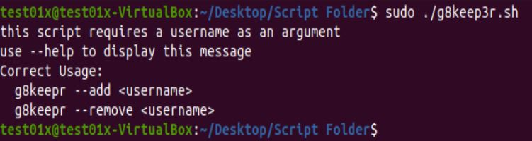

If the user runs the script without argument (username).

**Add the username to the watchlist file.**

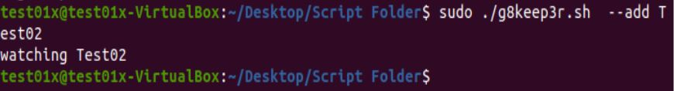

If the user wants to manually add the username to the watchlist file.

**Remove the username from the watchlist file.**



If the user wants to manually remove the username from the watchlist file.

**Prevent duplicate usernames if there is an existing username in the watch file.**

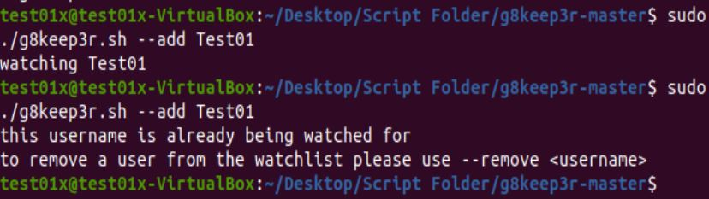

This test shows that the user can’t add the same username if it is already on the watchlist file.

**Show list of banned usernames**

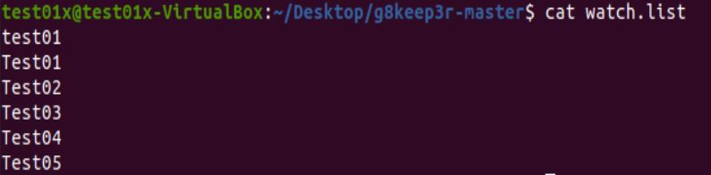

**Show iptable banned the test user with localhost IP**

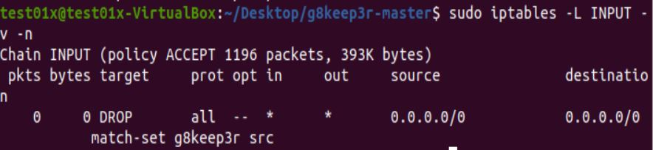

Match-set g8keep3r src shows that the localhost user got banned due to the “watchlist” file.

Please watch the Video for a much better showcase of my script.